Financial Functions in Excel
(A very nice sample sheet for Solver can be found here: SOLVSAMP.XLS --
Be sure that you have the Solver Add-in installed: If not, go to "Tools/Add-ins" and select "Solver Add-in")
Here are some commonly used financial functions in Excel:
There are 4 quantities that are interelated:
- Present Value (PV) = the value of the load or savings today.
- Interest Rate per period (RATE) = the interest rate, usually monthly (if given an annual rate, be sure to divide by 12!)
- Number of payment periods (NPER) = Number of payment periods (number of months usually).
- Periodic payment (PMT) = The payment per period (monthly payment usually). This value is the same for every payment period.
Given any 3 of the above 4 quantities, you can calculate the 4'th.
Use the following functions to calculate the missing value:

PMT
  - Used to calculate the fixed periodic payment, given the present value, the periodic interest rate and the total number of payments.
  - Note that if you are given an annual interest rate, you must divide it by the number of payment periods per year (12 for monthly payments).
  - Some sub-calculations involving the monthly payment that are used in creating amortization tables are:
    - IPMT
      - Calculates the interest portion of a PMT for a given month. The NPer input is the number of elapsed payment periods, not the total number of payment periods.
    - PPMT
      - Calculates the principal portion of a PMT for a given month. The NPer input is the number of elapsed payment periods, not the total number of payment periods.

NPER
  - Used to calculate the total number of payment periods needed to pay off a given present value with a given periodic payment and a given periodic interest rate.
  - Note that if you are given an annual interest rate, you must divide it by the number of payment periods per year (12 for monthly payments).

RATE
  - Used to calculate the periodic interest rate required to pay off a given present value with a given periodic payment and a given total number of payments. Note that if you want the annual interest rate, you must multiply this result by the number of payment periods per year (12 for monthly payments).

PV
  - Used to calculate the size loan that could be paid of given a given periodic payment over a given total number of payments and a given periodic interest rate.
  - Note that if you are given an annual interest rate, you must divide it by the number of payment periods per year (12 for monthly payments).

Another function that is commonly used in financial worksheets:

FV
  - The future value is the value of a loan or investment after a series of periodic payments.
  - The FV function is used to calculate the future value, given a periodic interest rate, the number of payment periods elapsed at the time of when future value is to be determined (i.e. it is not necessarily the total number of payments!), the payment amount and the present value.
  - The FV function can be used both to see the running balance in a loan amortization table (may produce the negative of the desired number however) or to see the result of a periodic investement (savings).

An example worksheet that uses all these functions can be downloaded here: finance.xls --
Amoritize: To amortize a loan is to calculate a series of constant periodic payments to pay off both the principal (present value) of a loan as well as all accrued interest, based on a given periodic interest rate and a given total number of payments.
Amortization Table: An amortization table is a table that shows the interest being paid, the principle being paid and the current balance for each payment period of a loan. If the interest rate is constant, the interest and principle payments should sum to a constant value, which can be directly calculated using the PMT function.

Calculating Loan Payments Using Excel's PMT Function
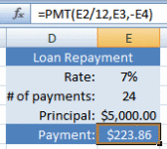
Excel 2007 PMT Function
The PMT function, one of Excel's Financial functions, can be used to calculate the payments for a loan or the future value of an investment.
The syntax for the PMT function is:
= PMT ( rate , nper , pv , fv , type )
rate - the annual interest rate for the loan.
nper - the total number of payments for the loan.
pv - the present value or the amount borrowed or the "principal of the loan.
fv - future value - for a loan this will be $0.00. For loans this argument can be omitted.
type - indicates when payments are due:
- "0" (or omitted) - at the end of the period ie: end of the month.
- "1" - at the beginning of the period ie: beginning of the month.
Example Using Excel 2007's PMT Function to Calculate Loan Payments:
Note: In this example, both the future value and type arguments have been omitted (see the image to the right).
- Enter the following data into cells:
D2 - Rate:
D3 - # of payments:
D4 - Principal:
D5 - Payment:
E2 - 7%
E3 - 24
E4 - $5,000.00
- Click on cell E5 - the location where the results will be displayed.
- Click on the Formulas tab.
- Choose Financial functions > PMT from the ribbon to bring up the function's dialog box.
- Click on the Rate line in the dialog box.
- Click on cell E2 in the spreadsheet.
- After the E2, type a forward slash " / " followed by the number 12 in the Rate line of the dialog box. This gives you the interest rate per month.
- Click on the Nper line in the dialog box.
- Click on cell E3 in the spreadsheet.
- Click on the Pv line in the dialog box.
- Type a minus sign ( - ) and then click on cell E4 in the spreadsheet.
- Click OK in the dialog box.
- The answer $223.86 appears in cell E5.
- When you click on cell E5 the complete function = PMT ( E2/12 , E3 , - E4 ) appears in the formula bar above the worksheet.

Excel functions for personal financial decisions: the PV, FV, PMT, PPMT, and IPMT functions
When we borrow money to buy a car or a house, we always wonder whether we're getting a good deal. When we save for retirement, we're curious how large a nest egg we'll have when we retire. In our daily work and personal life, financial questions similar to these questions often arise. Knowing how to use the PV, FV, PMT, PPMT, and IPMT functions in Excel makes answering these types of questions easy.

Should I pay $11,000 today for a copier or $3,000 a year for 5 years?
The key to answering this question is attributing a value to the annual payments of $3,000 per year. Let's assume the cost of capital is 12 percent per year. We could use the NPV function to answer this question, but the PV function provides a much quicker means to solve this problem.
The PV function returns the value in today’s dollars of a series of future payments, assuming periodic, constant payments and a constant interest rate. A stream of cash flows that includes the same amount of cash outflow (or inflow) each period is called an annuity, and assuming that each period’s interest rate is the same, an annuity can be valued using the PV function. Here's the syntax for the PV function:
PV(rate,#per,[pmt],[fv],[type])
- rate is the interest rate per period. If you borrow money at 6 percent per year and the period is a year, rate equals 0.06. If the period is a month, rate equals 0.06/12, or 0.005.
- #per is the number of periods in the annuity. In our copier example, #per equals 5. If payments for the copier are made each month for 5 years, #per equals 60. Your rate must be consistent with #per, of course. In other words, if #per implies that a period is a month, you need to use a monthly interest rate. If #per implies that a period is a year, use an annual interest rate.
- pmt is the payment made each period. In our example, pmt is $5,000. A payment is a positive number, while money received is a negative number.
- fv is the cash balance (or future value) that you want to have after the last payment is made. In our copier example, fv equals 0. (If we want a $5,000 cash balance after the last payment, fv would equal $5,000.) If fv is omitted, it's assumed to equal 0.
- type is either 0 or 1. Type indicates when payments are made. If type is omitted or equal to 0, payments are made at the end of each period. When type equals 1, payments are made at the beginning of each period.
The solution to the question about the best way to pay for the copier is included in the file PV.xls, shown in the following figure.
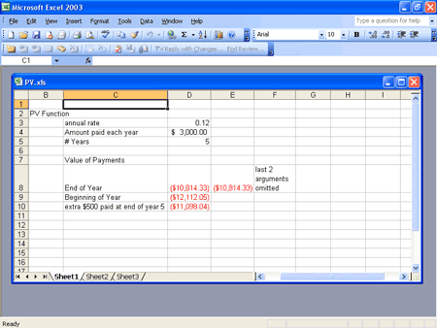
In cell D8, I computed the present value of paying $3,000 per year for 5 years (at the end of each year) with a 12 percent cost of capital. Here's the formula I used:

PV(annual_rate,Years,Amount_paid_each_year,0,0)
I named the cells D3:D5 with the labels in C3:C5 by pointing to Name on the Insert menu, and then clicking Create. Excel returns a net present value of -$10,814.33. (The negative sign means we are paying money out.) By omitting the last two arguments, I obtain the same answer in cell E8 with the formula:

PV(annual_rate,Years,Amount_paid_each_year)
Making payments at the end of the year is a better deal than paying out $11,000 today.
To calculate the net present value of the payments if we make payments of $3,000 on the copier for 5 years at the beginning of each year, I used this formula in cell D9:

PV(annual_rate,Years,Amount_paid_each_year,0,1)
Changing the last argument from a 0 to a 1 changes the calculation, which is now based on payments at the beginning of the year rather than payments at the end of the year. With this change, the present value of the payments is $12,112.05, so it's better to pay $11,000 today than to make payments at the beginning of the year.
Suppose we pay $3,000 at the end of each year and we have to include an extra $500 payment at the end of year 5. We can find the present value of all our payments by including a future value of $500, using the following formula:

PV(annual_rate,Years,Amount_paid_each_year,500,0)
In this calculation, the present value of the payments equals $11,098.04.

If I invest $2,000 a year for 40 years toward my retirement and earn 8 percent a year on my investments, how much will I have when I retire?
In this situation, we want to know the value of an annuity in future dollars (40 years from now) and not in today’s dollars. This is a job for the FV or future value function. The future value function calculates the future value of an investment assuming periodic, constant payments with a constant interest rate. The syntax of the FV function is as follows:

FV(rate,#per,[pmt],[pv],[type])
- rate is the interest rate per period. In our example, rate is 0.08.
- #per is the number of periods in the future at which you want to compute the future value. #per is also the number of periods during which the annuity payment is received. In our case, #per equals 40.
- pmt is the payment made each period. In this example, pmt is -$2,000. The negative sign indicates we are receiving money.
- pv is the amount of money (in today’s dollars) owed right now. In our case, pv equals $0. If we owed someone $10,000 today, pv would equal $10,000. If we had $10,000 in the bank today, pv would equal -$10,000. If pv is omitted, it's assumed to equal zero.
- type is 0 or 1, and it indicates when payments are due or money is deposited. If type equals 0 or is omitted, money is deposited at the end of a period. In our example, type is 0 or omitted. If type equals 1, payments are made or money is deposited at the beginning of a period.
The file FV.xls, shown in the following figure, contains the resolution to this question. In cell B7, I've entered the formula FV(Rate,Years,-Annual_deposit,0,0) to find that in 40 years our nest egg will be worth $518,113.04. Notice that I entered a negative value for our annual payment because a deposit can be viewed as a negative payment. In cell C7, I obtained the same answer by omitting the last two (unnecessary) arguments. The formula entered in C7 is FV(Rate,Years,Annual_deposit). If deposits are made at the beginning of each year for 40 years, the formula entered in cell B8, which is FV(Rate,Years,-Annual_deposit,0,1), yields the value of our nest egg in 40 years, $559,562.08.
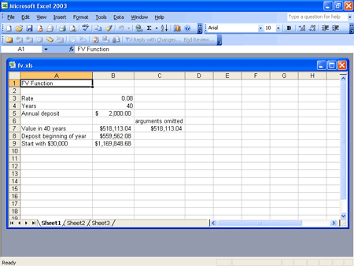
Finally, suppose that in addition to investing $2,000 at the end of each of the next 40 years, we have $30,000 with which to invest initially. If we earn 8 percent per year on our investments, how much money will we have when we retire in 40 years? We can answer this question by setting pv equal to -$30,000 in the FV function. (The negative sign indicates that we have money rather than owe someone money.) In cell B9 the formula:

FV(Rate,Years,-Annual_deposit,0,0)+FV(Rate,Years,0,-30000,1)
yields a future value of $1,169,848.68. The formula FV(Rate,Years,0,-30000,1) yields the future value (in 40 years) of $30,000 received today. The formula includes type = 1 because $30,000 is received today. I used a negative sign with the $30,000 because we are "owed" -$30,000. By the way, because our money is growing at 8 percent a year, FV(Rate,Years,0,-30000,1) simply yields (1.08)40($30,000).

I am borrowing $10,000 on a 10 month loan with an annual interest rate of 8 percent. What will my monthly payments be? How much principal and interest am I paying each month?
The Excel PMT function computes the periodic payments for a loan, assuming constant payments and a constant interest rate. The syntax of the PMT function is:

PMT(rate,#per,pv,[fv],[type])
- rate is the per period interest rate on the loan. In our example, we'll use one month as a period, so rate = 0.08/12, or 0.006666667.
- #per is the number of payments made. In our case, #per = 10.
- pv is the present value of all our payments. That is, pv is the amount of the loan. In our case, pv equals $10,000.
- fv is an optional argument that indicates the cash balance you want after making the last payment. In our case, fv is 0. If fv is omitted, Excel assumes it is 0. If you want to have all but $1,000 of the loan paid off at the end of 10 months, fv would equal -1,000.
- type is 0 or 1 and indicates when payments are due. If type equals 0 or is omitted, payments are made at the end of the period. In this example, we'll first assume end of month payment. If type is 1, payments are made (or money deposited) at the beginning of the period.
You can find an example of the PMT function in the file PMT.xls, shown in the following figure. In cell G1, I computed the monthly payment on a 10-month loan for $10,000, assuming an 8 percent annual rate and end-of-month payments. The formula is:

PMT(rate,months,loan_amount)
(Note that I used the names in cell range D1:D3 for the cell range E1:E3.) The monthly payment is $1,037.03.
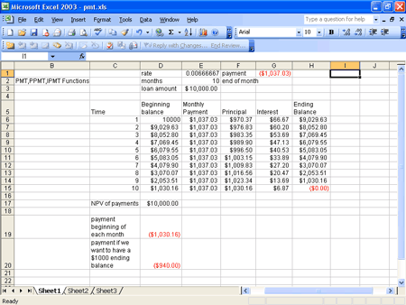
If you want, you can use the IPMT or the PPMT function to compute the amount of interest paid each month toward the loan and the amount of the balance paid down each month (called the payment on the principal).
To determine the interest paid each month, use the IPMT function. The syntax of the function is:

IPMT(rate, per, #per, pv, [fv],[type])
Except for the per argument, the arguments for the IPMT function are the same as for the PMT function. The per argument indicates the period number for which you're computing the interest.
Similarly, to determine the amount paid toward the principal each month, use the PPMT function. The syntax of the PPMT function is:

PPMT(rate, per, #per, pv, fv, type)
The meaning of each argument is the same as for the IPMT function.
By copying from F6 to F7:F15 the formula:

-PPMT(rate,C6,months,loan_amount)
I compute each month’s payment toward the principal. For example, during month 1, only $970.37 is paid toward principal. (As expected, the amount paid toward principal increases each month.) The minus sign is needed in the formula because the natural convention of Excel is to label a payment as negative.
By copying from G6 to G7:G15 the formula:

-IPMT(rate,C6,months,loan_amount)
I compute the amount of interest paid each month. For example, in month 1 we pay $66.67 in interest. Of course, the amount of interest we pay each month decreases. Note that each month (Interest Paid) + (Payment Toward Principal) = (Total Payment). Sometimes the total is off by a penny because of rounding.
I can also create ending balances for each month in column H by using the relationship (Ending Month t Balance) = (Beginning Month t Balance) – (Month t Payment toward Principal).
With a beginning balance of $10,000 in month 1, we create each month’s beginning balance in column D by using the relationship (Beginning Month t Balance) = (Ending Month t-1 Balance), where t = 2, 3, and so on up to 10. Of course, at the end of month 10, the balance is $0, as we'd expect.
Our interest each month can be computed as follows:

(Month t Interest) = (Interest rate)*(Beginning Month t Balance)
For example, for month 3 the interest is (0.0066667)*($8,052.80) = $53.69. Note, of course, that the net present value of all our payments is exactly $10,000. We checked this in cell D17 by using the formula NPV(rate,E6:E15). (See the following figure.)
If we make payments at the beginning of each month, the amount of each payment is computed in cell D19 with the formula:

PMT(rate,months,loan_amount,0,1)
Changing the last argument to 1 changes the timing of each payment to the beginning of the month. Because our lender is getting her money earlier, our monthly payments are less than in the end of the month case. If we pay at the beginning of the month, our monthly payment is $1,030.16.
Finally, suppose that we want to leave $1,000 of our loan balance unpaid at the end of 10 months. If we make payments at the end of the month, the formula PMT(rate,months,loan_amount,-1000), entered in cell D20, computes our monthly payment. Our monthly payment turns out to be $940.00. Because we are leaving $1,000 of our balance unpaid, it makes sense that our new monthly payment is less than the original end of month payment, $1,037.03.
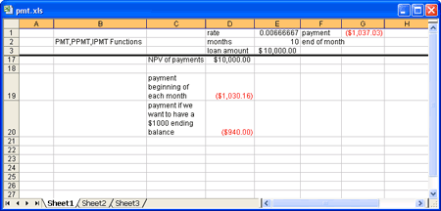

Problems
- You have just won the lottery. At the end of each of the next 20 years, you'll receive a payment of $50,000. If the cost of capital is 10 percent per year, what's the present value of your lottery winnings?
- A perpetuity is an annuity that is received forever. If I rent my house and at the beginning of each year receive $14,000, what is the value of this perpetuity? Assume an annual cost of capital of 10 percent. (Hint: use the PV function and let the number of periods be large!)
- I now have $250,000 in the bank. At the end of each of the next 20 years, I withdraw $15,000 to live on. If I earn 8 percent per year on my investments, how much money will I have in 20 years?
- I deposit $1,000 per month (at the end of each month) over the next 10 years. My investments earn 0.8 percent per month. I would like to have $1,000,000 in 10 years. How much money should I deposit now?
- An NBA player is receiving $15 million at the end of each of the next 7 years. He can earn 6 percent per year on his investments. What is the present value of his future revenues?
- At the end of each of the next 20 years, I will receive the following amounts:
Years | Amounts
1-5 | $200
6-10 | $300
11-20 | $400
- Use the PV function to find the present value of these cash flows if the cost of capital is 10 percent. Hint: Begin by computing the value of receiving $400 a year for 20 years, and then subtract the value of receiving $100 a year for 10 years, and so on.
- We are borrowing $200,000 on a 30-year mortgage with an annual interest rate of 10 percent. Assuming end of month payments, determine the monthly payment, interest payment each month, and amount paid toward principal each month.
- Answer each question in problem 7 assuming beginning of month payments.
- Use the FV function to determine the value to which $100 accumulates in three years if you are earning 7 percent per year.
- You have a liability of $1,000,000 due in 10 years. The cost of capital is 10 percent per year. What amount of money would you need to set aside at the end of each of the next 10 years to meet this liability?
- You are going to buy a new car. The cost of the car is $50,000. You have been offered two payment plans:
  - A 10 percent discount on the cost of the car, followed by 60 monthly payments financed at 9 percent per year.
  - No discount on the cost of the car, but the 60 monthly payments are financed at only 2 percent per year.
If you believe your annual cost of capital is 9 percent, which payment plan is a better deal? Assume all payments occur at the end of the month.
- I currently have $10,000 in the bank. At the beginning of each of the next 20 years, I am going to invest $4,000, and I expect to earn 6 percent per year on my investments. How much money will I have in 20 years?
- A balloon mortgage requires you to pay off part of a loan during a specified time period, and then make a lump sum payment to pay off the remaining portion of the loan. Suppose you borrow $400,000 on a 20-year balloon mortgage and the interest rate is .5 percent per month. Your end of month payments during the first 20 years are required to pay off $300,000 of your loan, and 20 years from now you will have to pay off the remaining $100,000. Determine your monthly payments for this loan.

